Save MyKāingaOra to your home screen
This is how you add MyKāingaOra to the home screen of your phone or other device.

It’s easier to open MyKāingaOra from the home screen of your phone or other device, instead of typing the web address into an internet browser all the time.
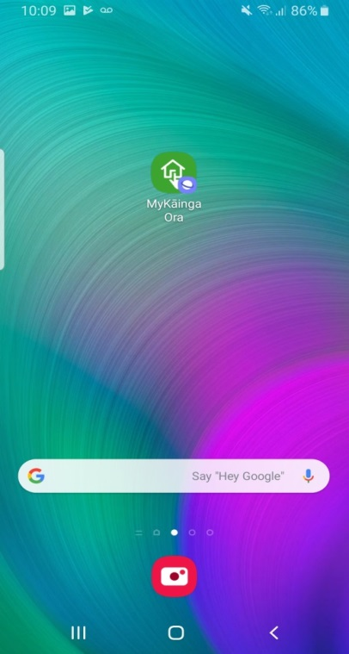

Contents

iPhone, iPad, iPod Touch 3
Android 6
Windows 8, 8.1 and RT 9
Windows Phone 10
Instructions for another device 10
Instructions removing a website from your home screen 10

iPhone, iPad, iPod Touch
Step | Action
1 | Open Safari 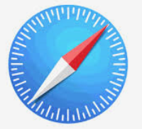and go to https://my.kaingaora.govt.nz
2 | Tap the ‘Share’ icon on the browser’s toolbar.  - On an iPad, it’s on the bar at the top of the screen  - On an iPhone or iPod Touch, it's on the bar at the bottom of the screen.  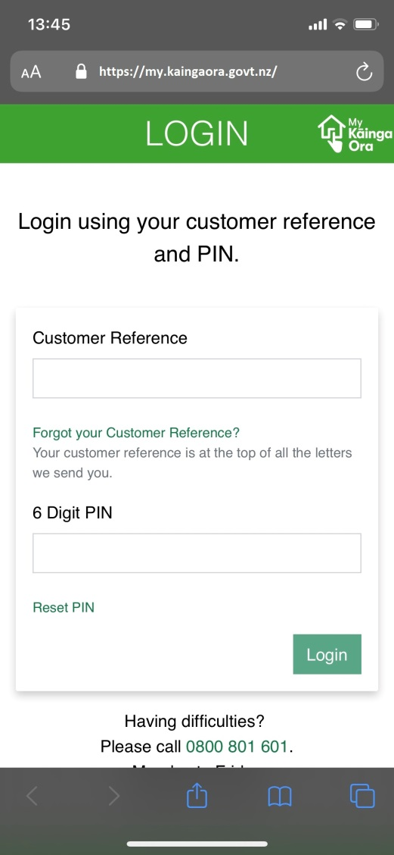
3 | Tap the 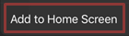 icon  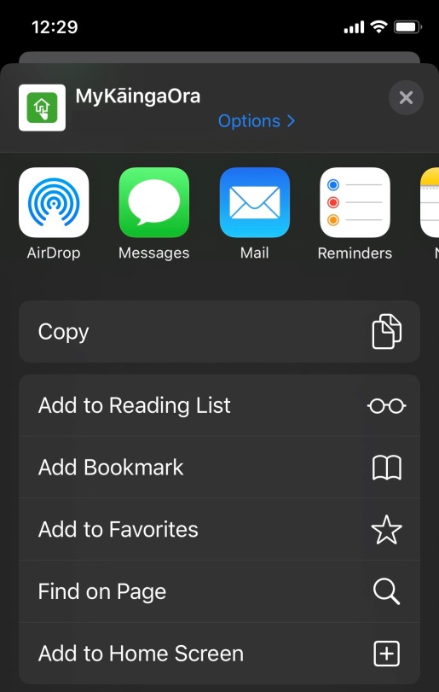
4 | The name of the weblink will auto generate leave it to MyKāingaOra  Tap on  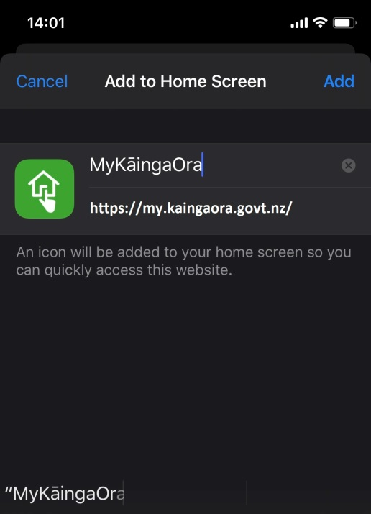
 | Well done! MyKāingaOra is now saved on your home screen.

Android
If you use an Android device, there are several popular browsers that will let you save websites to your home screen. The two most common are Google Chrome and Firefox.
If you have Google Chrome:
Step | Action
1 | Open Google Chrome 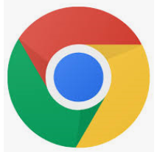and go to https://my.kaingaora.govt.nz
2 | Tap the menu button then Tap 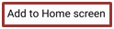  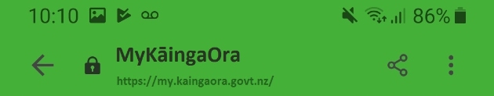  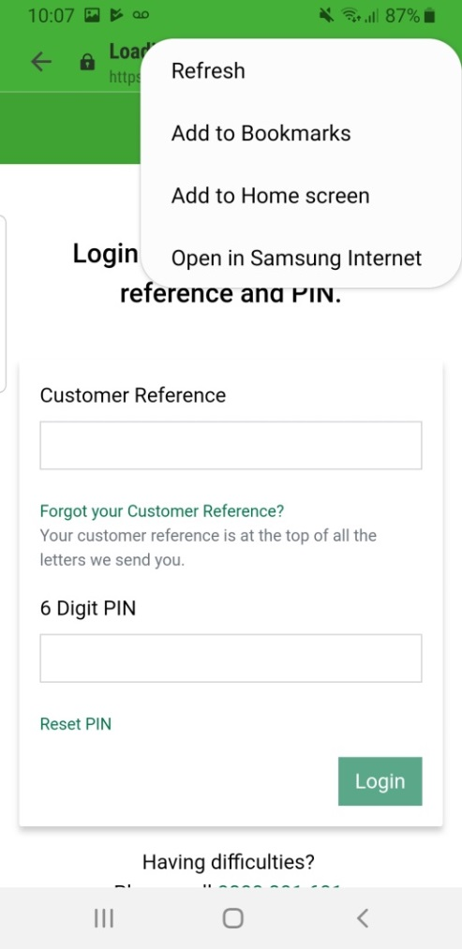
3 | Tap  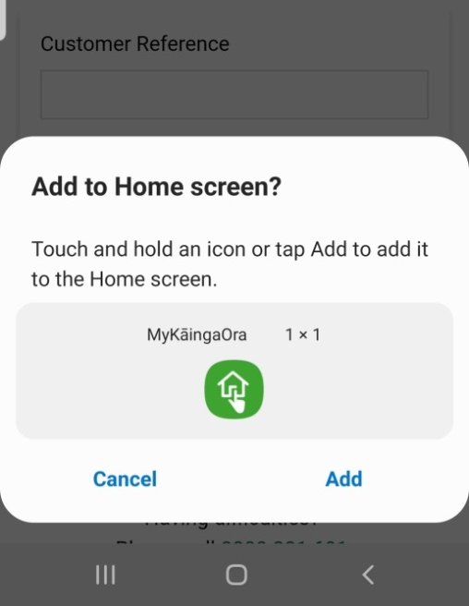  MyKāingaOra will now be added to your phone home screen.  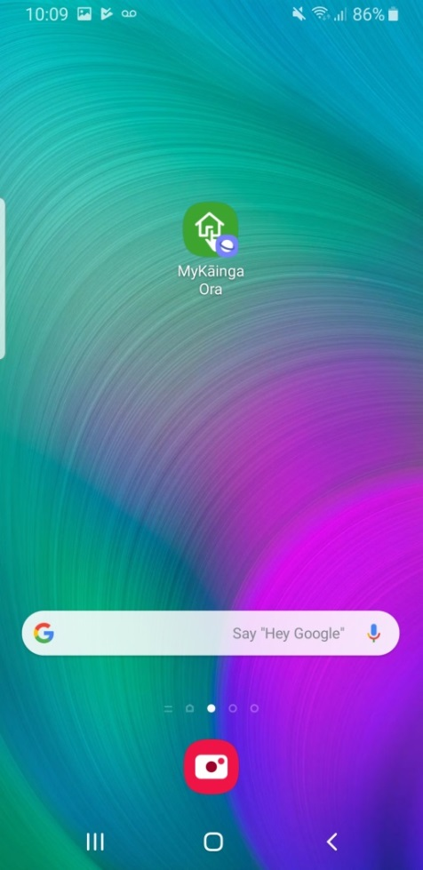

If you have Firefox:
Step | Action
1 | Open Firefox and go to https://my.kaingaora.govt.nz  Tap the menu button.  Tap the ‘Page’ option.  Tap ‘Add to Home Screen’

Windows 8, 8.1 and RT
If you use one of these devices, you can pin websites to your:
- ‘Start’ screen (usually if you’re using a tablet)
- Taskbar, desktop or Start menu (usually if you’re using a desktop PC).
Step | Action
1 | Open Internet Explorer and go to https://my.kaingaora.govt.nz
2 | Pull up the app bar — you can do this by right-clicking or swiping up from the bottom of your screen.
3 | Tap the star icon
4 | Tap the pin icon
5 | Enter a name for the website.
6 | Select ‘Pin to Start’.  The website will appear as a tile on your Start screen.

To pin to your Taskbar, desktop or Start menu:
If you have the Google Chrome browser:
Step | Action
1 | Open Google Chrome and go to https://my.kaingaora.govt.nz
2 | Click the menu button.
3 | Select ‘Tools’.
4 | Select ‘Create application shortcut’.
5 | Tick either:  - 'Desktop'  - 'Start menu'  - 'Pin to Taskbar'.
6 | Select 'Create'.

If you have the Internet Explorer browser:
Step | Action
1 | Open Internet Explorer and go to https://my.kaingaora.govt.nz
2 | Drag and drop the favicon (the icon to the left of the address in the address bar) to your taskbar.

Windows Phone
If you have a windows phone, you can save websites to your start screen.
Step | Action
1 | Open Internet Explorer and go to https://my.kaingaora.govt.nz
2 | Tap the ‘More’ button.
3 | Tap ‘Pin to start’.

Instructions for another device
If you have another type of device, you should be able to save websites to your home screen in a similar way.
Step | Action
1 | Open the browser you have on your device and go to https://my.kaingaora.govt.nz
2 | Tap the menu button.
3 | Look for an option called something like ‘Add to home screen’ or ‘Pin to home screen.’

Instructions removing a website from your home screen
You can easily remove any website from your home screen.
Step | Action
1 | Press the website icon and hold it down until a cross appears in the top corner.
2 | Tap the menu button.
3 | Tap the cross to delete the icon.

